Flight Disruption Rebooking Assistant

Overview
Build a small airline disruption assistant with LangGraph: a passenger whose flight was cancelled or delayed sends a message, and agents work out what they need, find a solution, check it against airline policy, and reply. The scope is about 2 to 3 days of work, and each part exercises a core LangGraph concept.
LangGraph concept | Where you use it
StateGraph and a typed state | RebookingState shared by every node
Nodes and edges | Each agent or step is one node
Conditional edges | Routing to the right specialist; policy pass or fail
Tool-calling loop | Rebooking Agent + ToolNode + tools_condition
A cycle with a counter | Policy Checker sends a failed solution back for another try
Checkpointer and threads | A passenger's follow-up message continues the same conversation

Business Scenario
Passengers contact the airline after a disruption. Example messages:
- "My flight to Dubai was cancelled. I need to be there by tomorrow noon."
- "My flight is delayed 6 hours. Am I entitled to anything?"
- "My flight was cancelled and I want my money back."
- "This is the third time you've cancelled on me. I want to speak to a manager."
For each message, the system must decide:
- What the passenger wants: rebooking, a refund, compensation, or to complain.
- Which solution fits the passenger's booking and constraints.
- Whether that solution follows airline policy.
- Whether a human agent needs to take over.

Workflow
The reference graph has 8 nodes, 3 conditional routing decisions and one cycle. Trainees may change names or layout, as long as every concept in the table above is used.
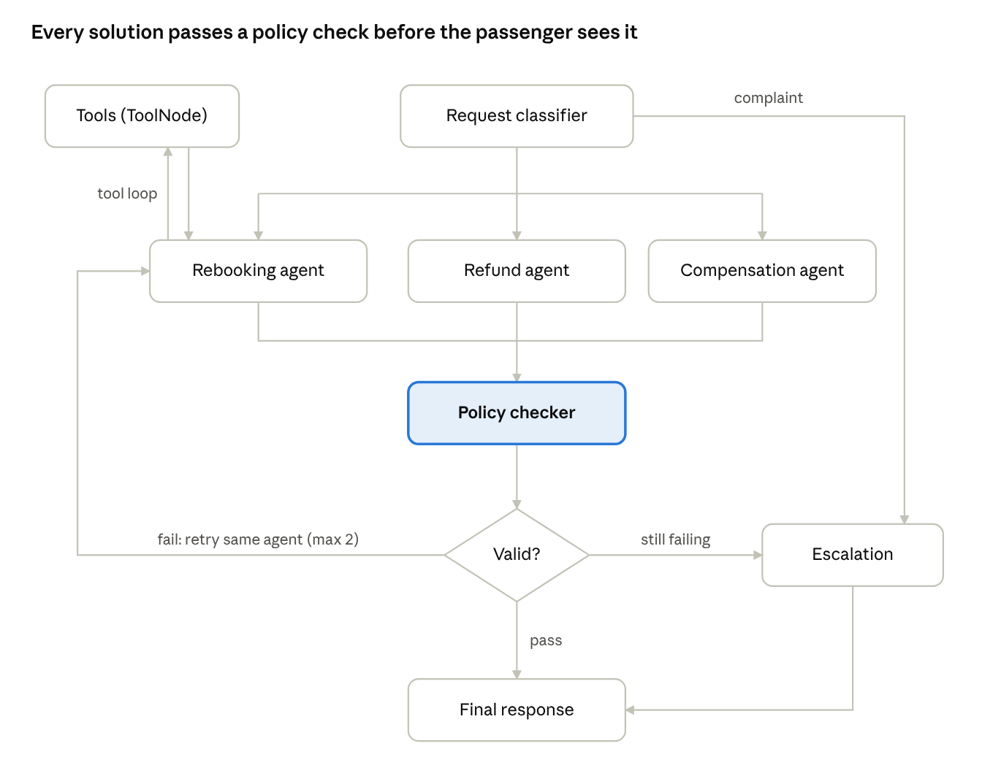
reference workflow · 8 nodes, 3 routing decisions, 1 cycle
A solution that fails the policy check goes back to the agent that produced it, with the reason attached. After two failed retries, the case goes to Escalation.

Functional Requirements

1. Request Intake
The graph is invoked with a passenger message:
{
"request_id": "R-7702",
"booking_ref": "XK9L2P",
"message": "My flight to Dubai was cancelled. I need to be there by tomorrow noon."
}

2. Request Classifier Agent
Uses structured output to extract into state:
- Intent: rebook, refund, compensation or complaint
- Constraints: for example, a latest arrival time
Route to the Rebooking, Refund or Compensation Agent. Complaints go straight to Escalation.

3. Rebooking Agent
An LLM with tools bound to it. It loops with a ToolNode to read the booking and search flights, then proposes one new flight that meets the passenger's constraints.

4. Refund Agent
Reads the booking and fare rules and proposes a refund amount.

5. Compensation Agent
Reads the booking and the delay length and proposes a compensation amount.

6. Policy Checker Node
A plain Python node (no LLM) that checks the proposed solution against the rules below.
Request | Rule
Rebook | Same cabin class or lower; departs within 48 hours; connection time at least 60 minutes
Refund | Airline cancelled: full fare. Passenger choice on a non-refundable fare: taxes only
Compensation | Delay under 3 hours: $0. 3 to 6 hours: $200. Over 6 hours or cancelled: $400
If the check fails, store the reason in state and route back to the agent that proposed the solution. After 2 failed retries, route to Escalation. Keep the retry count in state.

7. Escalation Agent
Writes a short handover note for a human agent: the passenger's request, what was tried, and why it could not be resolved.

8. Final Response Agent
Writes the reply to the passenger:
- What happened and what was arranged (new flight, refund or compensation)
- Next steps
- Whether a human agent will follow up

9. Follow-up Messages
The passenger can send a second message on the same thread_id, such as "Actually, can I get a refund instead?". The graph must use the booking and history already saved in state, without asking for the booking reference again.

State, Tools and Technical Requirements

State design
Design your own state as a TypedDict. How you structure it is part of the evaluation. At a minimum it must hold:
- The passenger's request and the conversation history (using a reducer)
- The classified intent and the passenger's constraints
- The booking details
- The proposed solution
- The policy check result and the reason for any failure
- The retry count and escalation status
- The final response

Tools
Implement three mock tools that return fixed fake data, so each test scenario gives the same result every run.
Tool | Used by | Returns
get_booking(booking_ref) | All agents | Passenger, route, cabin class, fare type, disruption details
search_flights(origin, destination, date) | Rebooking Agent | A list of flights with times, cabin availability and connections
get_fare_rules(fare_type) | Refund Agent | Refundable or not, and the tax amount
Include at least one search result that breaks a policy rule (for example, only business class available), so the retry loop can be tested.

Technical requirements
- StateGraph with at least 6 nodes
- At least 2 conditional edges written by you, plus tools_condition for the tool loop
- A ToolNode for tool execution
- At least 1 cycle with a retry counter that guarantees the graph ends
- A checkpointer (MemorySaver is enough) and a thread_id per passenger conversation
- Print or save the graph diagram with graph.get_graph().draw_mermaid()

Deliverables
- Source code on GitHub
- README covering the graph diagram, each node's responsibility, the state design, the routing logic, the policy rules, the tools, and how the checkpointer is used
- Four test scenarios, each showing the input message, the path taken through the graph, and the final response
# | Scenario | Expected path
1 | Cancelled flight, must arrive by noon | Classifier → Rebooking ⇄ Tools → Policy checker (pass) → Final response
2 | 6-hour delay, asks about compensation | Classifier → Compensation → Policy checker (pass) → Final response
3 | Only business-class seats available | Classifier → Rebooking ⇄ Policy checker (fails 3 times: first try + 2 retries) → Escalation → Final response
4 | Complaint asking for a manager | Classifier → Escalation → Final response
Scenario 1 must continue with a follow-up message on the same thread_id ("Actually, can I get a refund instead?") that routes to the Refund Agent.

Evaluation Criteria

Criterion | What is checked | Points
Runs end to end | All 4 scenarios and the follow-up message run without errors using the submitted instructions
Conditional routing | Each scenario follows the expected path; routing logic is in conditional edges, not hidden inside nodes
Tool calling | The Rebooking Agent chooses which tools to call; ToolNode loop works; tool use is visible in state
Policy check and retry cycle | Rules are applied correctly; failure feedback reaches the agent; the retry limit always ends the loop
State design | Clear typed state; reducer used for messages; each node updates only its own fields
Persistence | The follow-up message on the same thread_id reuses saved state without asking for the booking again
README and test evidence | Graph diagram, clear explanation of design decisions, and the output of each scenario
Code quality | Readable structure, prompts kept separate from logic, no API keys in the repo
A submission that does not run scores 0 for "Runs end to end" and "Conditional routing".

Submission and Rules
- Submit the link to a GitHub repository by the deadline set by the instructor.
- The repository must include a README, a requirements.txt, a .env.example listing the required keys, and a single command that runs all four scenarios and the follow-up.
- All tools must be mocks; the project must run with one LLM API key and no other external services.
- Be ready to walk through your graph and explain your design choices in a short review session. Being unable to explain your own code may reduce your score.

Bonus Opportunities
Bonus work is optional. Each completed item earns up to 5 points, to a maximum of 10. Bonus points are only counted if the core scenarios run.
- Human-in-the-loop: use interrupt() so a supervisor approves any refund or compensation over $300
- Clarifying questions: if the passenger's constraints are unclear, pause and ask them before searching flights
- Long-term memory: use a LangGraph Store to remember passenger preferences (for example, aisle seat) across conversations
- Parallel search: search several airlines at once with Send and merge the results
- Persistent checkpointer: switch to SqliteSaver so conversations survive a restart
- Statistics: report the rebooking success rate, escalation rate and requests by intent

